ILDN National Enterprise Awards 2019
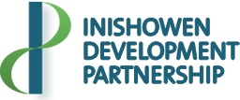

Application Form
The Irish Local Development Network (ILDN), which is the representative body of all Local Development Companies (LDCs) in Ireland and which includes the Inishowen Development Partnership, will host a National Enterprise Awards celebration in May 2019.
This Notice is to invite you, as an Inishowen business, to participate in the Border Regional Enterprise Awards which will be held on Friday 5th April 2019 in Cavan and if your Business is nominated to go further, you will take part in the National Finals to be hosted on 23rd May 2019 in Tullamore, Co. Offaly.
Awards will be presented to persons who have successfully set-up their own business with support from their Local Development Company and benefitting from the Back to Work Enterprise Allowance Scheme (BTWEAS or STEA).
Call to Action
This Invite is asking that you consider presenting your Business for consideration for a BTWEAS Award. Winning an Award is an opportunity to promote your business regionally and nationally.
What is involved?
Please complete and return the Application Form attached by email to the Enterprise Officer who supported your BTWEAS application, or by post, on or before 12 noon on Friday 8th March 2019.

Email: rosemary@inishowen.ie or sinead@inishowen.ie
Address: Inishowen Development Partnership, (IDP) Enterprise Unit,
St. Mary’s Road, Buncrana, Inishowen, Co. Donegal.

Please note, given the Regional and National deadlines set for this Initiative, IDP will not be able to accept Applications submitted after the Friday 8th March 2019.

Terms and Conditions
- Applications will only be accepted from individuals who have accessed BTWEAS or STEA from 1st January 2014 to 31st December 2018 and have engaged with the Inishowen Development Partnership during this process.
- All Applications will be considered by an “Adjudication Panel” comprised of members of the Inishowen Development Partnership Enterprise, Training, Social Enterprise and Employment Sub-Group.
- Please be aware that during the Awards process, you may be contacted with regard to your Award application, by a member of the “BTWEAS Adjudication Panel” but only if there is a requirement for clarification or for additional information in order to assess your Application fairly.
- Please be aware that the decision of the “Adjudication Panel” will be final and binding and there will be no Appeal process.
******************************************************************************
Please respond to the following statements by ticking the boxes as appropriate:

- I wish to be considered for the Local Development Company BTWEAS Enterprise Award Initiative, for which I am eligible.
- I agree to participate in all relevant “Publicity and Media Promotion” surrounding this Initiative, should I win an Award.
- Should I be successful as a BTWEAS Award recipient, I agree to participate in the Border Regional Enterprise Awards on Friday 5th April 2018 in Cavan and if nominated to go further, take part in the finals of the National Local Development Company (LDC) Enterprise Awards to be hosted on 23 May 2019 in Tullamore, Co. Offaly.
- I am fully Tax compliant.

I declare that all information provided by me is true and accurate.

Print Name: Date:
Signed: ____________________________________________
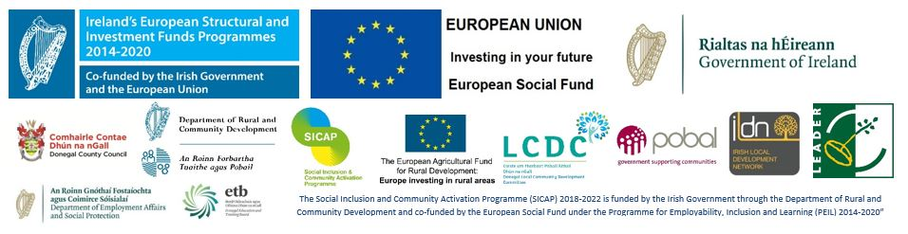

The Local Development Company Enterprise Awards 2019
APPLICATION FORM
1 Personal Details:
Name of Applicant(s)
Business Name:
Address:
Mobile Telephone No.:
E-mail:
2 Explain your background and previous work experience. (e.g Tell us about yourself, talk about your Education, Skills, Work Experience and Interests)

Please give a brief description of your Business type: (i.e. Tradesperson, Fitness Instructor, Beautician, Artist, Holistic Therapy etc.) and the service or product you and your business provide, e.g. what your business does)

Business Structure: (Tick as appropriate)
Sole Trader

Company

Partnership

3 Start-up date (month/year): ______________/____________

4 Please give details of the most significant achievement(s) e.g. Work Contracts, Work Orders, repeat Service Contracts, internationally traded services etc, business is now on-line, has an inter-active e-commerce Website for on-line sales as well as physical premises etc. since start up.

5 Please state the reasons why you think you as Promoter and your small Business should be considered for this Award:

6 Please describe, giving examples, of the future potential of your small business to
a) Expand (grow your business)

b) to increase your range of products, services and new business ideas (diversification) of your enterprise/business

7 Employment Creation
a) Number of Additional Full-time Jobs created ________________________
b) Number of Part-time Jobs created ________________________
c) Potential number of Jobs in total which are likely to be created in next year ________
d) Approximate number of indirect employment opportunities created to date since this business was established _____________

8. Please provide additional information which you believe would support your BTWEAS Application separately if necessary but restrict this information to a maximum of 2 A4 typed pages. The type of information which may help your Application may include: outlining barriers you have overcome to set up your own business, lessons learned, challenges you have experienced, in your personal or professional life, additional Education requirements, Skills e.g. IT or soft skills developed on the journey to self-employment, milestones achieved, success stories etc.

9 Briefly explain how BTWEA/STEA Scheme has benefited you and your Business.

ENDS
Please return this Form to Rosemary Lyons or Sinead McDaid, Enterprise Officer, Inishowen Development Partnership Office, St. Mary’s Road, Buncrana, Inishowen, Co. Donegal. Email rosemary@inishowen.ie or sinead@inishowen.ie on or before 8th March 2019

